**Report on World Ozone Day**

**Date:** 16th September 2024  
**Venue:** College Campus  
**Organized by:** Department of Science

The **Department of Science** at **Government Degree College, Gummalakshmipuram** celebrated **World Ozone Day** on **16th September 2024** to raise awareness about the importance of the ozone layer and the need to protect it for future generations.

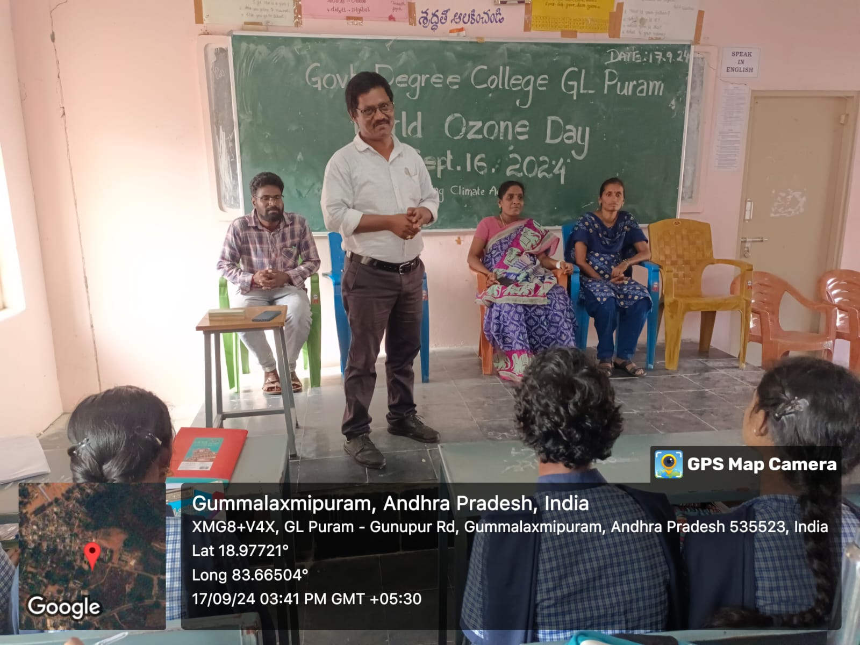

The event began with an awareness session in which **Sri D. Ramaiah**, Vice-Principal of the college, was invited as the **Chief Guest**. In his address, he emphasized the **vital role of the ozone layer** in protecting life on Earth from harmful ultraviolet radiation. He also highlighted practical measures to safeguard the ozone layer, such as:

* Planting more trees
* Reducing air pollution
* Avoiding the use of ozone-depleting substances
* Preventing deforestation and promoting green practices

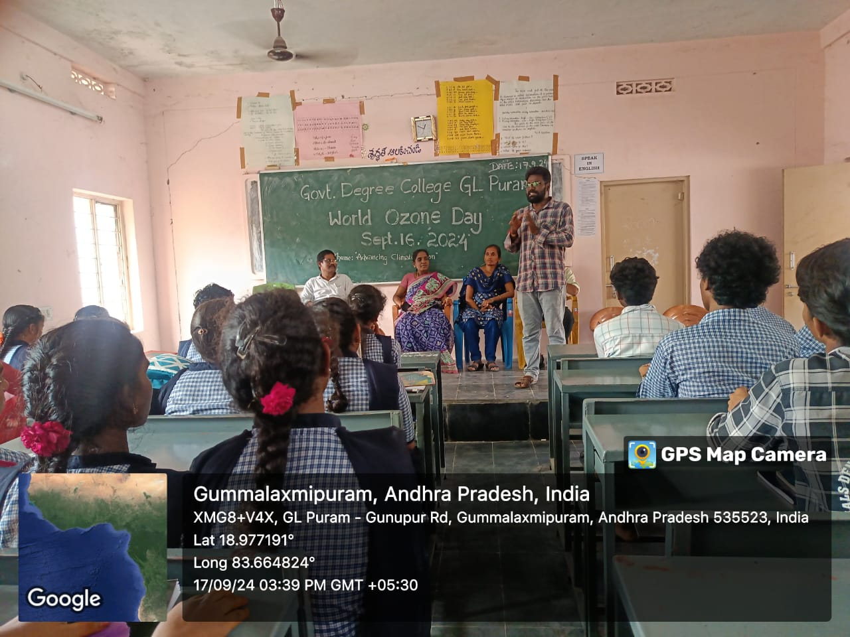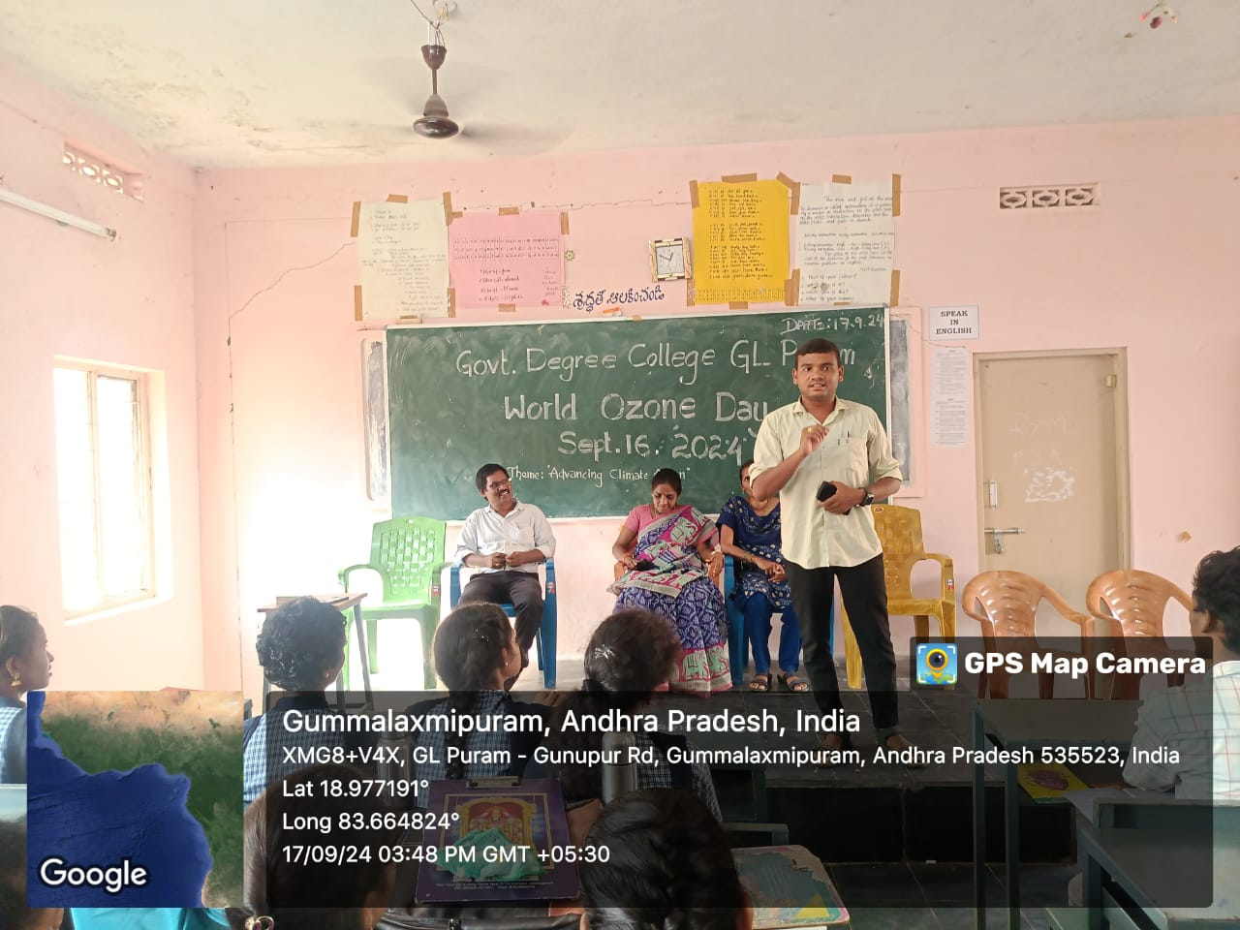

The science department lecturers — **K. Chinna Rao**, **T. Satya Rao**, **N. Srikanth**, **N. Santha**, along with co-coordinators **V. Kalpana**, **T. Srivani**, and **G. Tulasi** — played an active role in organizing and guiding the event.

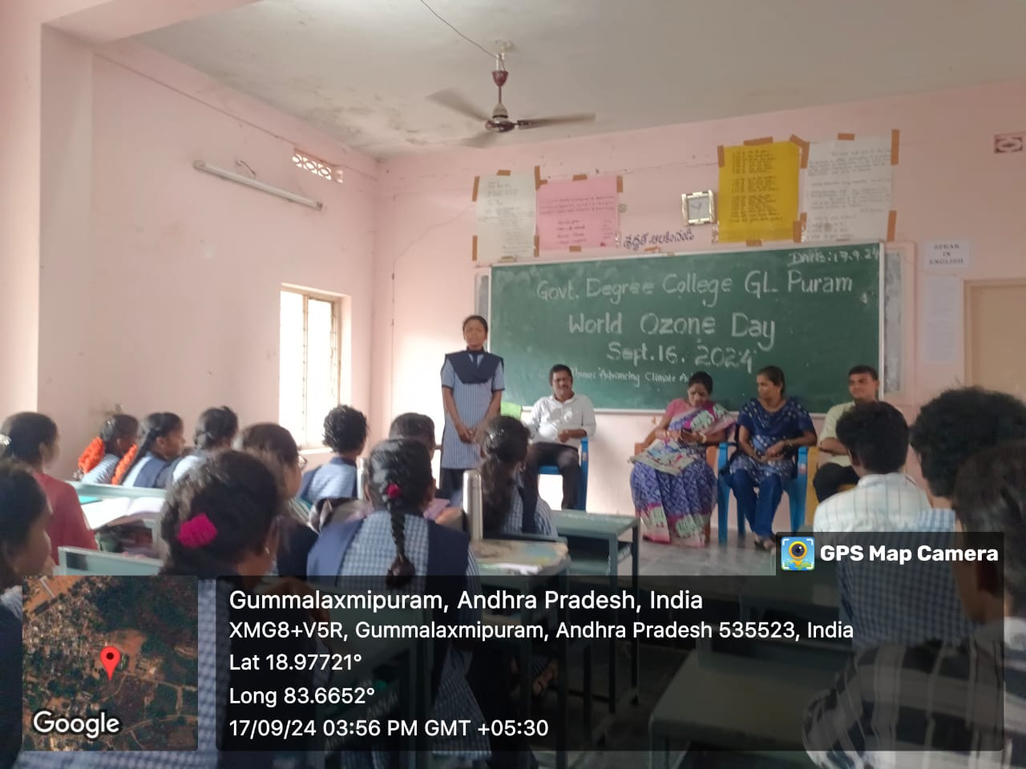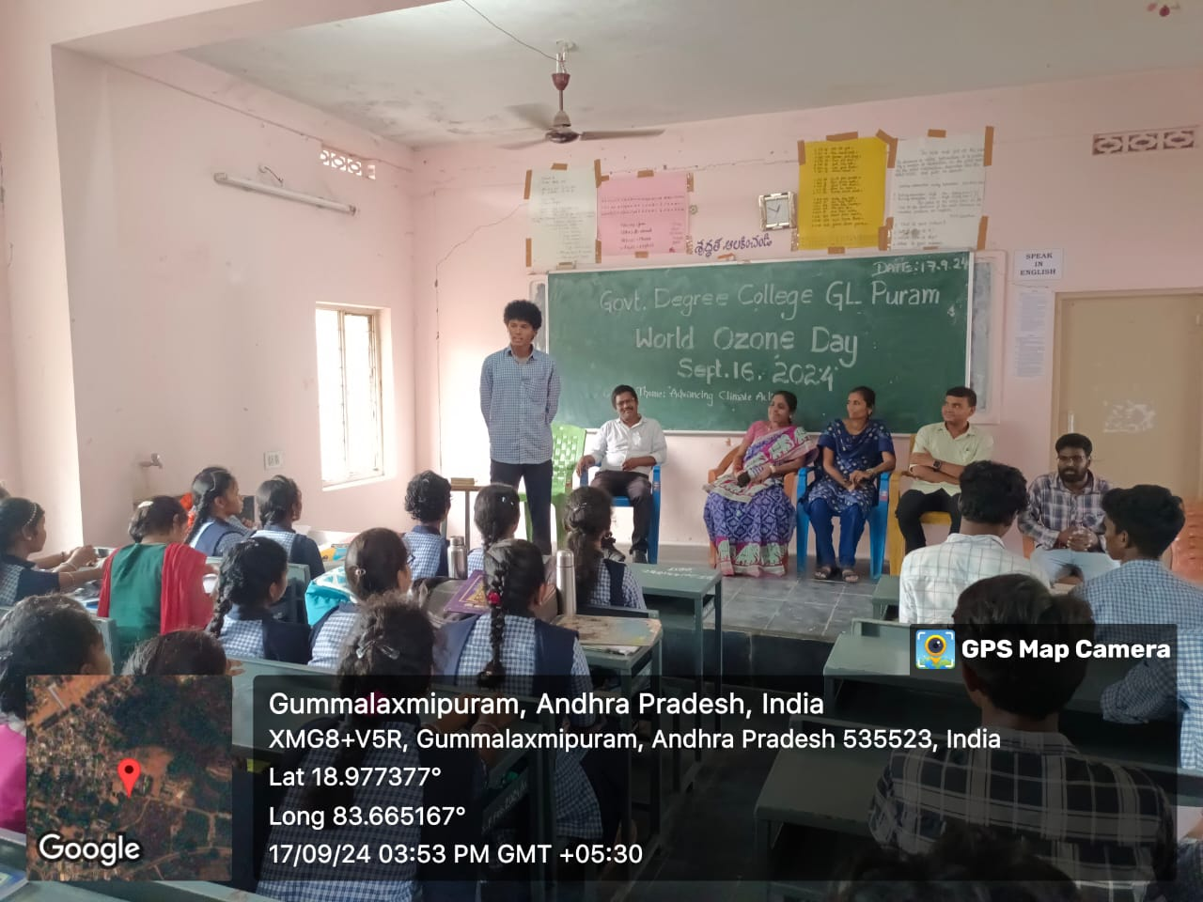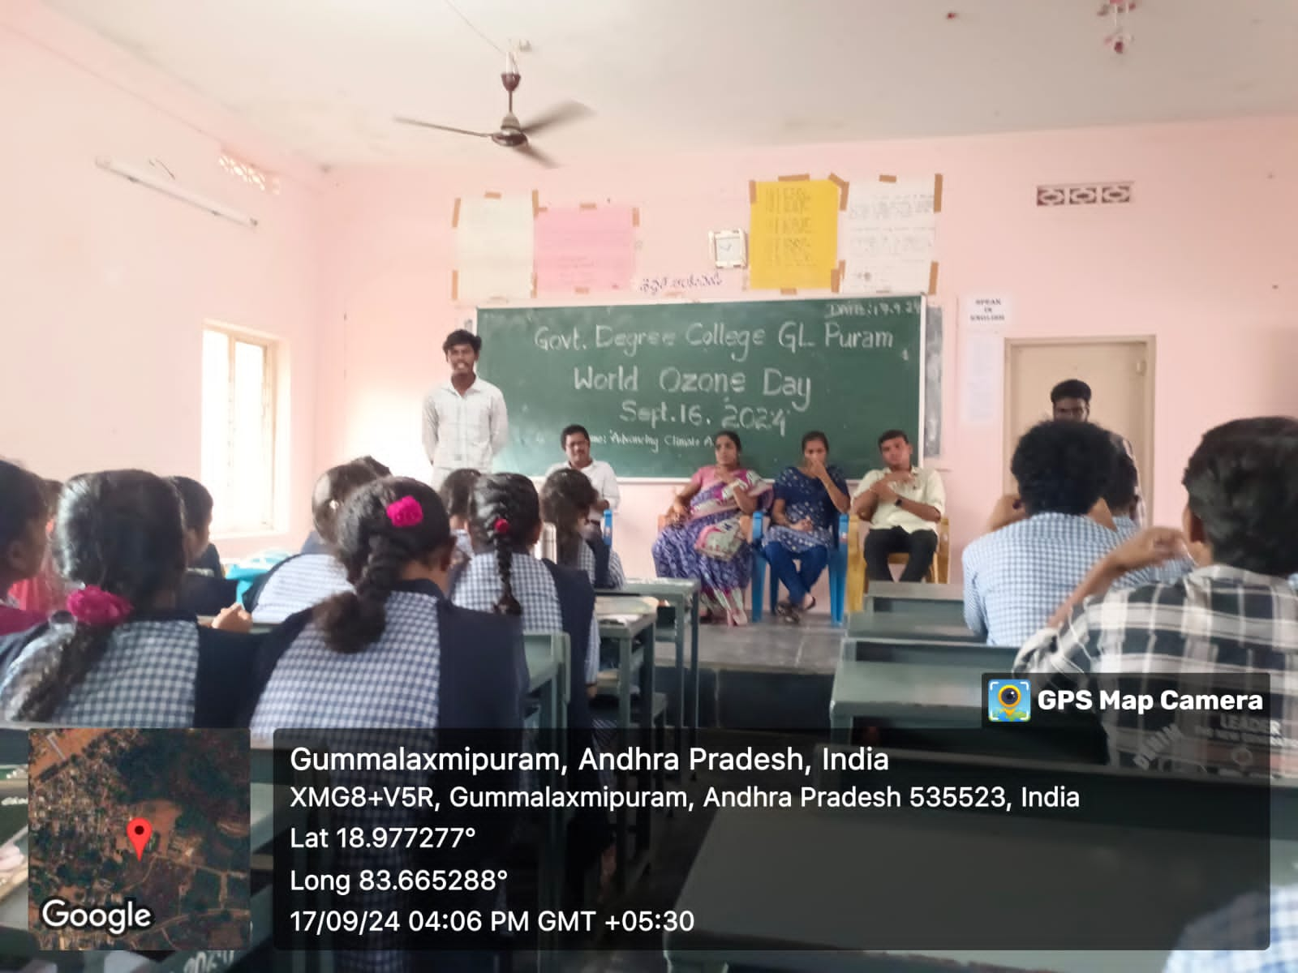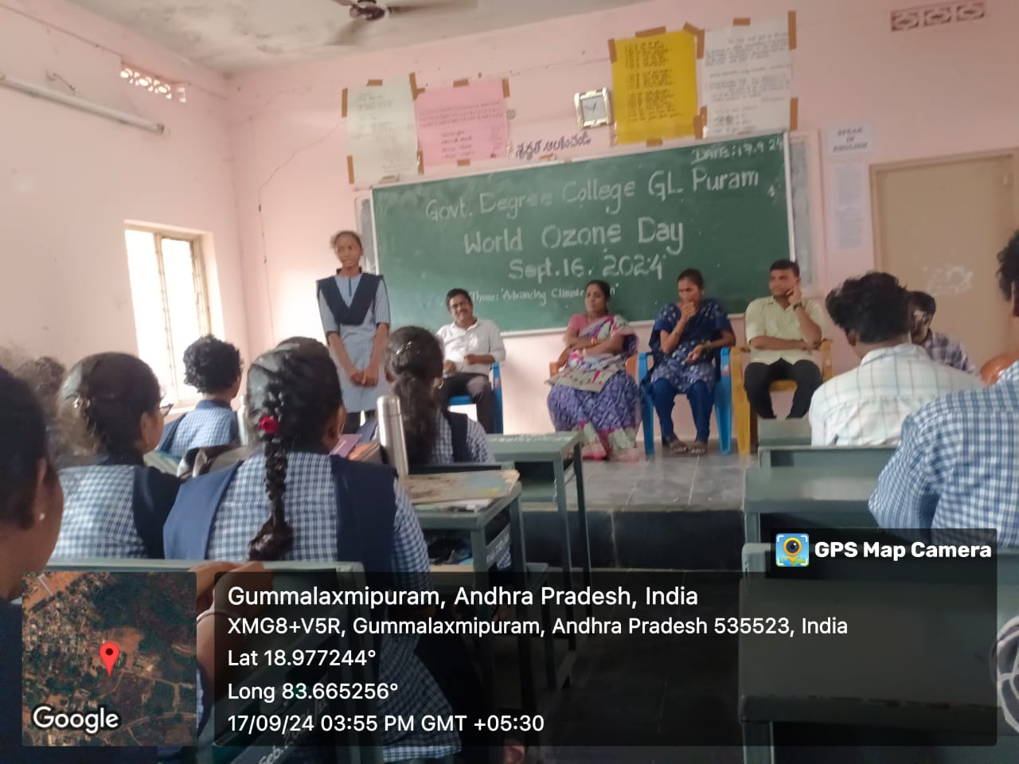

The programme saw the enthusiastic participation of nearly **60 students**, who took part in discussions, pledged to adopt eco-friendly practices, and engaged in a campus awareness activity. Educational posters and slogans were also displayed to reinforce the message of ozone protection.

The event concluded on a positive note with students and faculty taking a collective pledge to contribute towards **environmental sustainability** and protection of the **ozone layer**.